**Pengujian *Triaxial***

Nama : Saroha Saut Pasaribu

Nim : 2014 21 110

Pengaruh Penggunaan Serbuk Keramik Dan Abu Jerami Untuk Meningkatkan Nilai Kohesi Tanah Rawa

P

Judul Skripsi :

|  |
| --- |
|  |
|  |
|  |
|  |
|  |
|  |
|  |
|  |
|  |
|  |
|  |
|  |
|  |
|  |
|  |
|  |
|  |
|  |
|  |
|  |
|  |
|  |
|  |
|  |
|  |
|  |

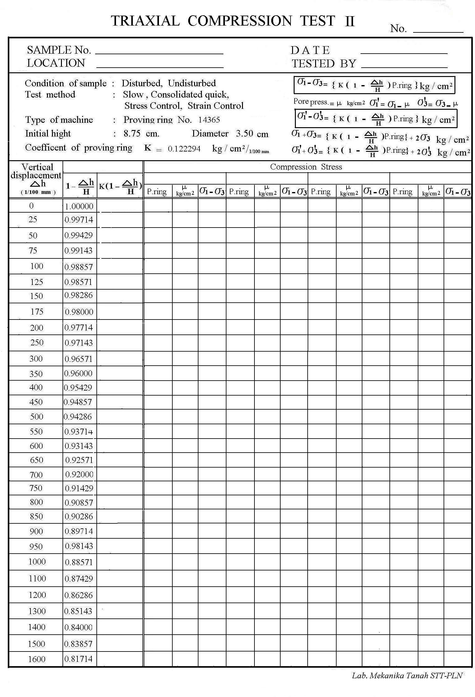Pembimbing : Irma Sepriyanna, ST .,MT

|  |  |  |  |  |  |  |  |  |  |  |  |  |
| --- | --- | --- | --- | --- | --- | --- | --- | --- | --- | --- | --- | --- |
| 0.1223 | 0 |  | **0.0000** | 0 |  | **0.0000** | 0 |  | **0.000** |  |  |  |
| 0.1219 | 0.2 |  | **0.0244** | 0.2 |  | **0.0244** | 0.6 |  | **0.012** |  |  |  |
| 0.1214 | 0.8 |  | **0.0973** | 1 |  | **0.1216** | 0.6 |  | **0.024** |  |  |  |
| 0.1210 | 1 |  | **0.1212** | 1.2 |  | **0.1455** | 0.8 |  | **0.097** |  |  |  |
| 0.1205 | 1 |  | **0.1209** | 1.4 |  | **0.1693** | 1.4 |  | **0.169** |  |  |  |
| 0.1201 | 1 |  | **0.1205** | 1.7 |  | **0.2049** | 1.8 |  | **0.217** |  |  |  |
| 0.1197 | 1.1 |  | **0.1322** | 1.8 |  | **0.2164** | 2 |  | **0.240** |  |  |  |
| 0.1192 | 1.2 |  | **0.1438** | 2 |  | **0.2397** | 2 |  | **0.239** |  |  |  |
| 0.1188 | 1.2 |  | **0.1434** | 2.2 |  | **0.2629** | 2.1 |  | **0.250** |  |  |  |
| 0.1179 | 1.3 |  | **0.1544** | 2 |  | **0.2376** | 2.5 |  | **0.297** |  |  |  |
| 0.1171 | 1.2 |  | **0.1417** | 2 |  | **0.2362** | 2.3 |  | **0.271** |  |  |  |
| 0.1162 | 1.2 |  | **0.1409** | 2.3 |  | **0.2700** | 2.4 |  | **0.281** |  |  |  |
| 0.1153 | 1.2 |  | **0.1400** | 2.6 |  | **0.3034** | 2.1 |  | **0.245** |  |  |  |
| 0.1144 | 1.1 |  | **0.1276** | 2.4 |  | **0.2784** | 1.8 |  | **0.208** |  |  |  |
| 0.1136 | 1.2 |  | **0.1384** | 2.1 |  | **0.2421** |  |  |  |  |  |  |
| 0.1127 | 1.7 |  | **0.1948** |  |  |  |  |  |  |  |  |  |
| 0.1118 | 1.1 |  | **0.1253** |  |  |  |  |  |  |  |  |  |
| 0.1109 | 1 |  | **0.1132** |  |  |  |  |  |  |  |  |  |
| 0.1101 |  |  |  |  |  |  |  |  |  |  |  |  |
| 0.1092 |  |  |  |  |  |  |  |  |  |  |  |  |
| 0.1083 |  |  |  |  |  |  |  |  |  |  |  |  |
| 0.1074 |  |  |  |  |  |  |  |  |  |  |  |  |
| 0.1066 |  |  |  |  |  |  |  |  |  |  |  |  |
| 0.1057 |  |  |  |  |  |  |  |  |  |  |  |  |
| 0.1048 |  |  |  |  |  |  |  |  |  |  |  |  |
| 0.1031 |  |  |  |  |  |  |  |  |  |  |  |  |
|  |  |  |  |  |  |  |  |  |  |  |  |  |
|  |  |  |  |  |  |  |  |  |  |  |  |  |
|  |  |  |  |  |  |  |  |  |  |  |  |  |
|  |  |  |  |  |  |  |  |  |  |  |  |  |
|  |  |  |  |  |  |  |  |  |  |  |  |  |

24 Mei 2018

Saroha Saut Pasaribu

Tanah + 0% S.Keramik + 0% A.Jerami

Lab Mekanika Tanah

|  |  |  |  |  |
| --- | --- | --- | --- | --- |
| 8,75 | 8,75 | 8,75 |  |  |
| 3.5 | 3.5 | 3.5 |  |  |
| 1 | 1 | 1 |  |  |
| 59,720 0,8070 | 59,72040,7969 | 59,7204 0,8875 |  |  |
| 2,2466 | 2,2878 | 1,9521 |  |  |
| 69,646 | 68,3933 | 80,1554 |  |  |
| 1 | 2 | 3 |  |  |
| 1,1948 | 2,2700 | 3,2970 |  |  |
|  |  |  |  |  |
|  |  |  |  |  |
|  |  |  |  |  |
|  |  |  |  |  |

|  |
| --- |
| 0.0841 |
|  |
|  |

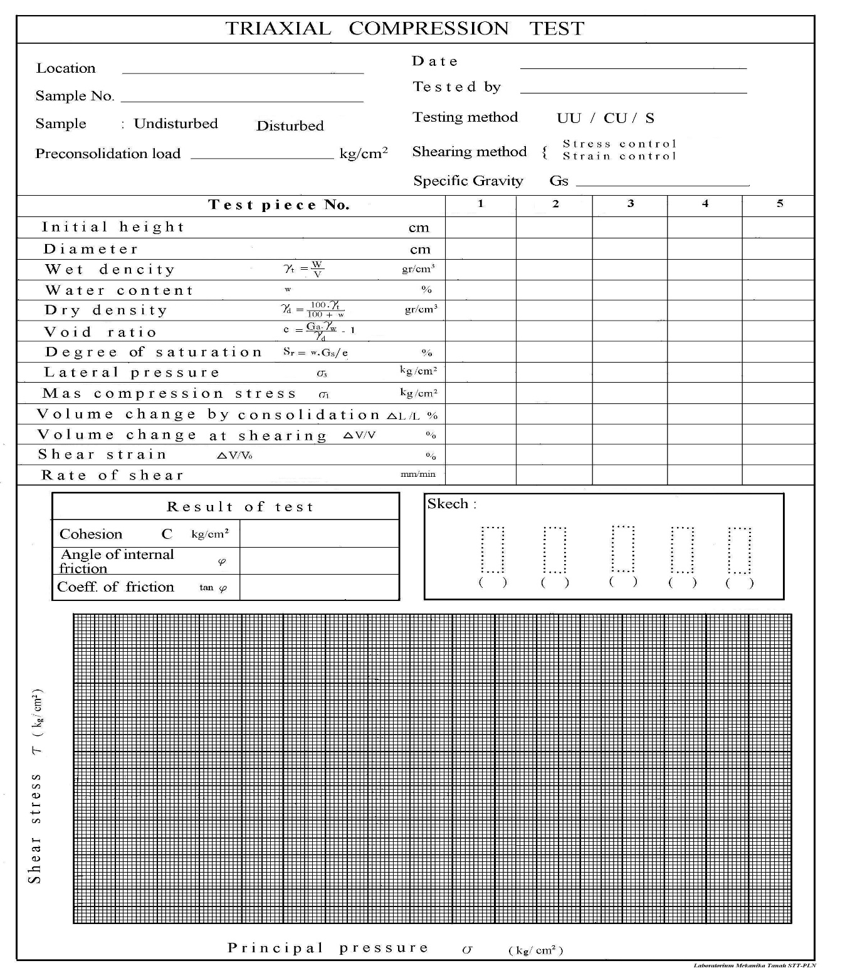

2.2917

24 Mei 2018

Saroha Saut Pasaribu

Lab. Mekanika Tanah

Tanah + 0% S.Keramik + 0% A.Jerami

Mengetahui,

Asisten Lab Mekanika Tanah STT PLN

(Jurkando Limbong)



24 Mei 2018

Saroha Saut Pasaribu

Tanah + 10% S.Keramik + 5% A.Jerami

Lab Mekanika Tanah

|  |  |  |  |  |  |  |  |  |  |  |  |  |
| --- | --- | --- | --- | --- | --- | --- | --- | --- | --- | --- | --- | --- |
| 0.1223 | 0 |  | **0.000** | 0 |  | **0.0000** | 0 |  | **0.0000** |  |  |  |
| 0.1219 | 1.3 |  | **0.1585** | 0.2 |  | **0.0244** | 0.2 |  | **0.1219** |  |  |  |
| 0.1214 | 1.8 |  | **0.2189** | 0.4 |  | **0.0486** | 1.8 |  | **0.2189** |  |  |  |
| 0.1210 | 2.6 |  | **0.3152** | 0.8 |  | **0.0970** | 3 |  | **0.3637** |  |  |  |
| 0.1205 | 3.1 |  | **0.3748** | 1.6 |  | **0.1934** | 3.9 |  | **0.4715** |  |  |  |
| 0.1201 | 2.8 |  | **0.4581** | 2.1 |  | **0.2531** | 4.6 |  | **0.5545** |  |  |  |
| 0.1197 | 4.1 |  | **0.4928** | 2.8 |  | **0.3366** | 4.8 |  | **0.5769** |  |  |  |
| 0.1192 | 4.8 |  | **0.5753** | 3.2 |  | **0.3835** | 5.1 |  | **0.6112** |  |  |  |
| 0.1188 | 4.9 |  | **0.5855** | 3.4 |  | **0.4063** | 5.2 |  | **0.6214** |  |  |  |
| 0.1179 | 5 |  | **0.5940** | 4 |  | **0.4752** | 5.3 |  | **0.6296** |  |  |  |
| 0.1171 | 5 |  | **0.5905** | 4.3 |  | **0.5078** | 5.2 |  | **0.6141** |  |  |  |
| 0.1162 | 5 |  | **0.5870** | 4.6 |  | **0.5401** | 5.1 |  | **0.5988** |  |  |  |
| 0.1153 | 4.9 |  | **0.5718** | 4.6 |  | **0.5368** | 4.8 |  | **0.5602** |  |  |  |
| 0.1144 | 4.9 |  | **0.5684** | 5 |  | **0.5800** |  |  |  |  |  |  |
| 0.1136 | 4.8 |  | **0.5535** | 4.5 |  | **0.189** |  |  |  |  |  |  |
| 0.1127 |  |  |  | 4 |  | **0.4584** |  |  |  |  |  |  |
| 0.1118 |  |  |  |  |  |  |  |  |  |  |  |  |
| 0.1109 |  |  |  |  |  |  |  |  |  |  |  |  |
| 0.1101 |  |  |  |  |  |  |  |  |  |  |  |  |
| 0.1092 |  |  |  |  |  |  |  |  |  |  |  |  |
| 0.1083 |  |  |  |  |  |  |  |  |  |  |  |  |
| 0.1074 |  |  |  |  |  |  |  |  |  |  |  |  |
| 0.1066 |  |  |  |  |  |  |  |  |  |  |  |  |
| 0.1057 |  |  |  |  |  |  |  |  |  |  |  |  |
| 0.1048 |  |  |  |  |  |  |  |  |  |  |  |  |
| 0.1031 |  |  |  |  |  |  |  |  |  |  |  |  |



|  |  |  |  |  |
| --- | --- | --- | --- | --- |
| 8,75 | 8,75 | 8,75 |  |  |
| 3.5 | 3.5 | 3.5 |  |  |
| 1 | 1 | 1 |  |  |
| 54,6398 | 54,6398 | 54,6398 |  |  |
| 0,8284 | 0,9097 | 0,8340 |  |  |
| 0.6932 | 0.6491 | 0.6679 |  |  |
| 67,7929 | 78,2691 | 68,4850 |  |  |
| 1 | 2 | 3 |  |  |
| 1,5940 | 2,5800 | 3,6296 |  |  |
|  |  |  |  |  |
|  |  |  |  |  |
|  |  |  |  |  |
|  |  |  |  |  |

24 Mei 2018

Saroha Saut Pasaribu

Lab. Mekanika Tanah

Tanah + 10% S.Keramik + 5% A.Jerami

1.7601

|  |
| --- |
| 0.2777 |
|  |
|  |

Mengetahui,

Asisten Lab Mekanika Tanah STT PLN

(Jurkando Limbong)



24 Mei 2018

Saroha Saut Pasaribu

Tanah + 10% S.Keramik + 10% A.Jerami

Lab Mekanika Tanah

|  |  |  |  |  |  |  |  |  |  |  |  |  |
| --- | --- | --- | --- | --- | --- | --- | --- | --- | --- | --- | --- | --- |
| 0.1223 | 0 |  | **0.0488** | 0 |  | 0 | 0 |  | 0 |  |  |  |
| 0.1219 | 0.4 |  | **0.0730** | 0.6 |  | **0.0732** | 1 |  | **.0.1219** |  |  |  |
| 0.1214 | 0.6 |  | **0.0970** | 0.7 |  | **0.0851** | 1.3 |  | **0.1581** |  |  |  |
| 0.1210 | 0.8 |  | **0.1088** | 1 |  | **0.1212** | 2 |  | **0.2425** |  |  |  |
| 0.1205 | 0.9 |  | **0.1085** | 1.5 |  | **0.1813** | 2.5 |  | **0.3022** |  |  |  |
| 0.1201 | 1.1 |  | **0.1322** | 2.1 |  | **0.2531** | 3.3 |  | **0.3978** |  |  |  |
| 0.1197 | 1.2 |  | **0.1438** | 2.5 |  | **0.3005** | 3.8 |  | **0.4568** |  |  |  |
| 0.1192 | 1.2 |  | **0.1434** | 3.1 |  | **0.3715** | 4.6 |  | **0.551** |  |  |  |
| 0.1188 | 2.6 |  | **0.3089** | 3.7 |  | **0.4421** | 5.4 |  | **0.645** |  |  |  |
| 0.1179 | 3.8 |  | **0.4488** | 4.5 |  | **0.5346** | 5.6 |  | **0.665** |  |  |  |
| 0.1171 | 4 |  | **0.4696** | 5 |  | **0.5905** | 5 |  | **0.590** |  |  |  |
| 0.1162 | 4.5 |  | **0.5252** | 5.4 |  | **0.6340** | 4.8 |  | **0.563** |  |  |  |
| 0.1153 | 4.8 |  | **0.5566** | 5.4 |  | **0.6302** |  |  |  |  |  |  |
| 0.1144 | 5.2 |  | **0.5996** | 5 |  | **0.5800** |  |  |  |  |  |  |
| 0.1136 | 4.9 |  | **0.5616** | 4.5 |  | **0.5189** |  |  |  |  |  |  |
| 0.1127 | 4 |  | **0.4556** |  |  |  |  |  |  |  |  |  |
| 0.1118 |  |  |  |  |  |  |  |  |  |  |  |  |
| 0.1109 |  |  |  |  |  |  |  |  |  |  |  |  |
| 0.1101 |  |  |  |  |  |  |  |  |  |  |  |  |
| 0.1092 |  |  |  |  |  |  |  |  |  |  |  |  |
| 0.1083 |  |  |  |  |  |  |  |  |  |  |  |  |
| 0.1074 |  |  |  |  |  |  |  |  |  |  |  |  |
| 0.1066 |  |  |  |  |  |  |  |  |  |  |  |  |
| 0.1057 |  |  |  |  |  |  |  |  |  |  |  |  |
| 0.1048 |  |  |  |  |  |  |  |  |  |  |  |  |
| 0.1031 |  |  |  |  |  |  |  |  |  |  |  |  |



|  |  |  |  |  |
| --- | --- | --- | --- | --- |
| 8.75 | 8.75 | 8.75 |  |  |
| 3.5 | 3.5 | 3.5 |  |  |
| 1 | 1 | 1 |  |  |
| 48,3079 | 48,3079 | 48,3079 |  |  |
| 0,8938 | 0,9153 | 0,8690 |  |  |
| 1,6146 | 1,5530 | 1,6892 |  |  |
| 69,9195 | 72,6907 | 66,8295 |  |  |
| 1 | 2 | 3 |  |  |
| 1,5996 | 2,6340 | 3,6653 |  |  |
|  |  |  |  |  |
|  |  |  |  |  |
|  |  |  |  |  |
|  |  |  |  |  |

24 Mei 2018

Saroha Saut Pasaribu

Lab. Mekanika Tanah

Tanah + 10% S.Keramik + 10% A.Jerami

1.9928

|  |
| --- |
| 0.2792 |
|  |
|  |

Mengetahui,

Asisten Lab Mekanika Tanah STT PLN

(Jurkando Limbong)



24 Mei 2018

Saroha Saut Pasaribu

Tanah + 10% S.Keramik + 15% A.Jerami

Lab Mekanika Tanah

|  |  |  |  |  |  |  |  |  |  |  |  |  |
| --- | --- | --- | --- | --- | --- | --- | --- | --- | --- | --- | --- | --- |
| 0.1223 | 0 |  | **0.0000** | 0 |  | **0.0000** | 0 |  | **0.0000** |  |  |  |
| 0.1219 | 0.6 |  | **0.0732** | 1.1 |  | **0.1341** | 1 |  | **0.1219** |  |  |  |
| 0.1214 | 2 |  | **0.2432** | 1.6 |  | **0.1946** | 1.8 |  | **0.2189** |  |  |  |
| 0.1210 | 3.6 |  | **0.4365** | 2 |  | **0.2425** | 2 |  | **0.2425** |  |  |  |
| 0.1205 | 4.8 |  | **0.5803** | 2.8 |  | **0.3385** | 2.4 |  | **0.2902** |  |  |  |
| 0.1201 | 5.8 |  | **0.6992** | 3.6 |  | **0.434** | 3.2 |  | **0.3858** |  |  |  |
| 0.1197 | 6 |  | **0.7212** | 4.4 |  | **0.5289** | 4.6 |  | **0.5529** |  |  |  |
| 0.1192 | 6 |  | **0.7191** | 4.8 |  | **0.5753** | 5 |  | **0.5992** |  |  |  |
| 0.1188 | 6.1 |  | **0.7289** | 5.1 |  | **0.6094** | 5.2 |  | **0.6214** |  |  |  |
| 0.1179 | 5.4 |  | **0.6415** | 6.1 |  | **0.7247** | 5.6 |  | **0.6653** |  |  |  |
| 0.1171 | 4 |  | **0.4724** | 6.4 |  | **0.7558** | 6.1 |  | **0.7204** |  |  |  |
| 0.1162 |  |  |  | 5.8 |  | **0.6809** | 6.6 |  | **0.7749** |  |  |  |
| 0.1153 |  |  |  | 5.2 |  | **0.6069** | 6.8 |  | **0.7936** |  |  |  |
| 0.1144 |  |  |  |  |  |  | 6.4 |  | **0.7424** |  |  |  |
| 0.1136 |  |  |  |  |  |  | 5.8 |  | **0.6688** |  |  |  |
| 0.1127 |  |  |  |  |  |  |  |  |  |  |  |  |
| 0.1118 |  |  |  |  |  |  |  |  |  |  |  |  |
| 0.1109 |  |  |  |  |  |  |  |  |  |  |  |  |
| 0.1101 |  |  |  |  |  |  |  |  |  |  |  |  |
| 0.1092 |  |  |  |  |  |  |  |  |  |  |  |  |
| 0.1083 |  |  |  |  |  |  |  |  |  |  |  |  |
| 0.1074 |  |  |  |  |  |  |  |  |  |  |  |  |
| 0.1066 |  |  |  |  |  |  |  |  |  |  |  |  |
| 0.1057 |  |  |  |  |  |  |  |  |  |  |  |  |
| 0.1048 |  |  |  |  |  |  |  |  |  |  |  |  |
| 0.1031 |  |  |  |  |  |  |  |  |  |  |  |  |



|  |  |  |  |  |
| --- | --- | --- | --- | --- |
| 8,75 | 8,75 | 8,75 |  |  |
| 3.5 | 3.5 | 3.5 |  |  |
| 1 | 1 | 1 |  |  |
| 40,4176 | 40,4176 | 40,4176 |  |  |
| 0,9168 | 0,9350 | 0,9776 |  |  |
| 1,5225 | 1,4731 | 1,3654 |  |  |
| 61,3898 | 63,4464 | 68,4511 |  |  |
| 1 | 2 | 3 |  |  |
| 1,7289 | 2,7558 | 3,7936 |  |  |
|  |  |  |  |  |
|  |  |  |  |  |
|  |  |  |  |  |
|  |  |  |  |  |

Lab. Mekanika Tanah

Tanah + 10% S.Keramik + 15% A.Jerami

24 Mei 2018

Saroha Saut Pasaribu

2.5692

|  |
| --- |
| 0,3414 |
|  |
|  |

Mengetahui,

Asisten Lab Mekanika Tanah STT PLN

(Jurkando Limbong)